**MEMO**

**To:** MOVE members, partners, and investors

**From:** Molly Fleming and Tim Lumpkins, MOVE

**RE:** MO 2020 Primary Election Initial c3 Analysis

**Date**: August 14, 2020

All told, 1,263,776 Missouri voters made it to the polls on August 4th. The following memo provides a topline report on Missouri’s primary election results as well as a summary of grassroots voter engagement infrastructure and its deliverables. While this report offers a summary analysis of immediately publicly available data and program reports, MOVE staff are working to sunshine voter-level election results in key counties. From this, we will provide a more detailed analysis of voter turnout and trends in the coming months. We will also update this document as we receive new information from our partners.

MOVE and MOVE Action member groups whose work is reflected here include Missouri Faith Voices (Impact), Missouri Jobs with Justice (Voter Action), Action St. Louis, NARAL Pro-Choice Missouri, the Organization for Black Struggle, Missouri Healthcare Action, Planned Parenthood Advocates of Missouri, SEIU Healthcare, Sierra Club, Heartland Action / MCU, MORE2, and Missouri Rural Action.

**Winning on Amendment 2 - Medicaid Expansion**

*A victory for public health and family pocketbooks, 230,000 Missourians will receive healthcare through the expansion of Medicaid.*

Despite monied opposition wielding [racialized wedge strategies](https://www.stltoday.com/opinion/editorial/editorial-if-the-truth-wont-defeat-amendment-2-let-lies-do-the-job/article_4fc0dd17-05f4-5451-9efa-bbdf2be9901f.html) and the challenges of navigating a midterm primary electorate in a pandemic, public health leaders and grassroots organizing infrastructure soundly passed Amendment 2 to expand Medicaid with a full 53.3% of Missouri voters supporting the measure.

**Yes Votes on Amendment 2 by County**

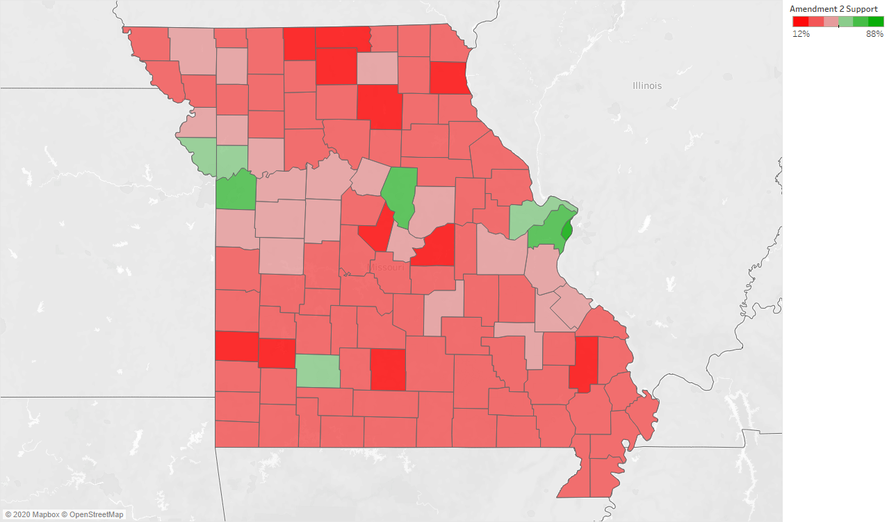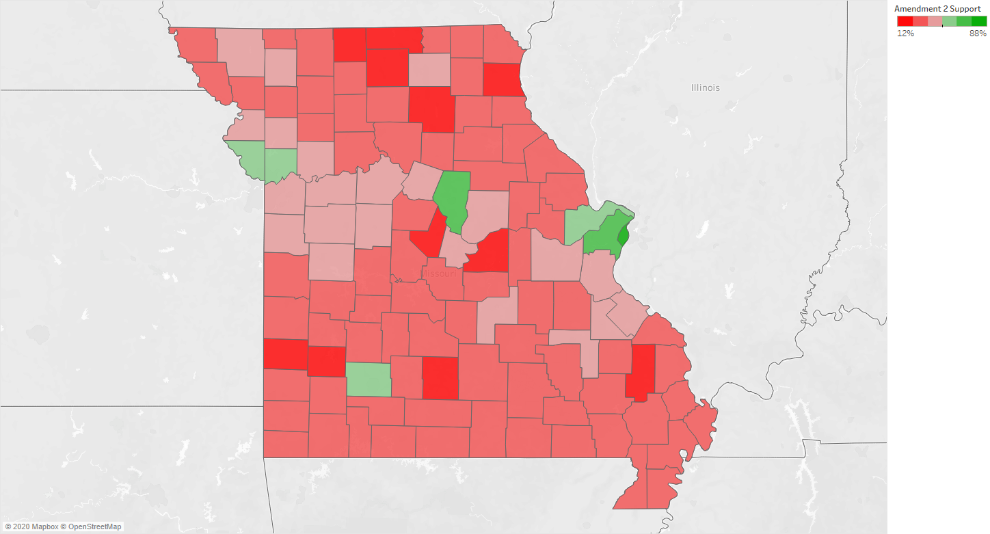

Support for uninsured Missourians and public health carried the day in 9 of Missouri’s 11 most populous counties, but failed to pass in a single rural county, as seen on the map on the previous page. That said, Amendment 2 did garner 175,960 rural votes (nearly 100,000 more votes than Democratic ballots cast), without which Medicaid expansion would not have prevailed.

Turnout Trends to Support Amendment 2 Victory

The state saw 535,676 Democratic ballots cast relative to 680,310 Republican ballots, a 65% increase in Democratic turnout from 2016’s August primary. These turnout increases are most notable in urban and suburban counties, as well as counities with a small city such as Greene (Springfield) and Jasper (Joplin), as illustrated below and detailed in Appendix II.

**Change in Democratic Primary Turnout by County, 2016 to 2020**

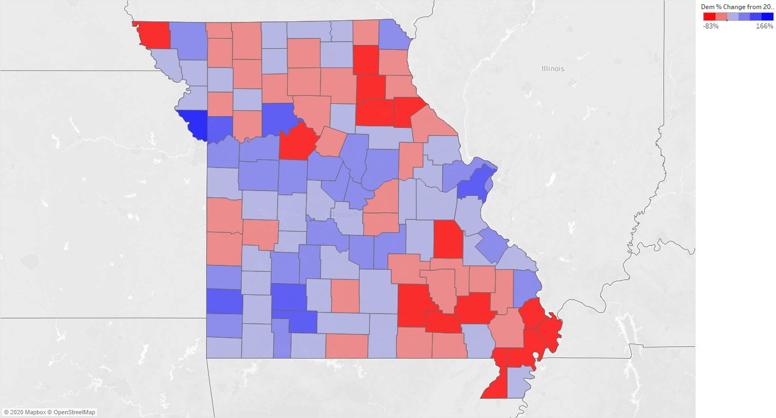

While Democratic turnout was a key element in Amendment 2’s overwhelming victory (potentially contributing over 210,263 otherwise unlikely Democratic voters against the measure, had 2016 turnout held), crossover support for Medicaid expansion was an equally critical element to its defeat. Extrapolating from statewide primary results and Amendment 2 results, we can estimate that well over 20% of Republican voters supported Amendment 2. Even if all Democratic voters supported Amendment 2 (highly unlikely), a minimum of over 137,291 Republicans also voted for the measure.[1] Further, 47,790 more people voted on Amendment 2 than on the gubernatorial primary on either side.[2]

Worth noting that Governor Parson moved the Medicaid Expansion vote from the November general election ballot to the August primary ballot in late May, with the Yes on 2 campaign left to very quickly develop a plan to win. Missouri primary electorates tend to be more Republican as turnout overall is lower, and Parson may not have wanted to face this issue during his own November re-election battle. Despite the political move, the suburban shift in Missouri was sufficient, when coupled with strong urban turnout, to push Medicaid expansion to its six point victory.

**Access to Voting**

*Voting rights restricted, but no major issues on Election Day.*

Missouri has some of the most restrictive voting laws in the nation, with [very limited access to vote-by-mail](https://www.brookings.edu/research/voting-by-mail-in-a-pandemic-a-state-by-state-scorecard/), most mail options requiring a notary. MOVE Action, MOVE’s c4 sister organization, prioritized an “absentee” chase program, mailing 49,851 Black voters who requested absentee ballots to encourage their return. Additionally, Missouri Jobs with Justice Voter Action called 26,899 voters who had been mailed ballots for return, with 2,589 direct conversations. The Missouri Voter Protection Coalition, led by former Advancement Project Senior Counsel Denise Lieberman, fielded 569 complaints, more than half of them before election day about challenges with early and absentee voting. In spite of these challenges, Missouri had record ballots submitted by mail. For example in St. Louis County, 81,000 ballots were submitted by mail, more than a third of votes cast.

The ACLU of Missouri has a case pending before the Missouri Supreme Court to lift the notary requirement for absentee voting in November.

**MOVE and MOVE Action Direct Voter Contact**

*Grassroots organizations across Missouri empower over 100,000 direct conversations with voters.*

Independent political organizations and grassroots leaders in Missouri have been working to develop the plans, policies and people it will take to build a majority coalition that wins and builds power in the next five years — and beyond. Missouri Organizing and Voter Engagement Collaborative (MOVE)[3] reflects this commitment the c3 coordinating table created to catalyze existing organizing towards voter engagement that can compel political transformation.

All told, our member and partner organizations ran the largest grassroots independent expenditure (IE) voter contact program in decades, targeting low propensity base voters across the state. These groups collectively gathered 104,653 signatures towards ballot qualification, completed 36,623 door knocks, made 909,525 calls, and sent 239,92 texts to have 108,235 direct conversations with voters. The bulk of this work was completed through coordinated, volunteer-driven grassroots infrastructure despite the challenges of remote organizing. Groups managed their own infrastructure during “pre-GOTV” and contributed shared staffing and volunteer shifts to a 10-day centralized GOTV program. Our collaborative developed and coached four new regional leads, 39 support staff and leaders (roles such as phonebank captain and texting lead), and 586 unique volunteers to drive this incredible turnout program.

Missouri Organizing and Voter Engagement Action (MOVE Action) is MOVE’s c4 sister organization. Many MOVE members are also members of MOVE Action, and much of the work of these partners was completed through c4 program. MOVE Action’s membership includes Missouri Faith Voices Impact, Missouri Jobs with Justice Voter Action, Action St. Louis, NARAL Pro-Choice Missouri, the Organization for Black Struggle, Planned Parenthood Advocates of Missouri, SEIU MO/KS State Council, Heartland Action, Missouri Rural Action, and the United Brotherhood of Carpenters.

A summary table of voter contact work by member and partner organization is on the next page, with detail by county in Appendix III.

**Direct Voter Contact Work by Grassroots Organizations**

|  |  |  |  |  |  |  |  |  |
| --- | --- | --- | --- | --- | --- | --- | --- | --- |
|  | **Signatures** | **Dials** | **Texts** | **Knocks** | **Total Convos** | **Medicaid IDs** | **Central. GOTV shifts** | **GOTV Lead Support Roles** |
| Action St. Louis (Power Project) | 2,408 | 18,575 | 22,250 | 36,622 | 10,900 | 9,115 | 3 | 0 |
| Heartland Action (MCU) | 13,252 | 16,224 | 5,294 | 0 | 3,661 | 2,820 | 238 | 5 |
| MO Faith Voices Impact | 719 | 5,830 | 0 | 0 | 1,884 | 1,349 | 91 | 3 |
| MO Health Care Action | 11,724 | 33,333 | 5,076 | 0 | 2,075 | 1,729 | 110 | 6 |
| MO Rural Action (MRCC) | 0 | 69,616 | 31,717 | 0 | 8,697 | 8,632 | 14 | 3 |
| MO Jobs with Justice Voter Action | 40,989 | 112,399 | 15,868 | 0 | 8,253 | 6,758 | 301 | 6 |
| MORE2 | 3,876 | 3,774 | 5,404 | 0 | 1,131 | 1,051 | 8 | 2 |
| NARAL | 4,863 | 46,101 | 14,609 | 0 | 4,517 | 3,502 | 113 | 2 |
| Organization for Black Struggle | 3,781 | 18,211 | 0 | 0 | 5,361 | 4,060 | 91 | 1 |
| Planned Parenthood Advocates | 4,161 | 18,855 | 31,357 | 0 | 3,690 | 2,932 | 67 | 5 |
| Our Revolution | 5,951 | 0 | 0 | 0 | 0 | 0 | 0 | 0 |
| Sierra Club | 7,803 | 0 | 0 | 0 | 24 | 22 | 1 | 0 |
| SEIU Healthcare | 0 | 0 | 0 | 0 | 819 | 273 | 7 | 3 |
| Other Grassroots | 5,126 | 0 | 0 | 0 | 3,802 | 2,585 | 212 | 3 |
| Centralized Grassroots GOTV | 0 | 495,203 | 108,345 | 0 | * | 2,875 | * | * |
| Absentee Chase Program | 0 | 29,285 | 0 | 0 | 2,589 | 1,523 | 0 | 0 |
| Tier 2 Universe (Vended) | 0 | 42,119 | 0 | 0 | 50,832 | 8,580 | 0 | 0 |
| **TOTAL** | **104,653** | **909,525** | **239,920** | **36,622** | **108,235** | **57,806** | **1,256** | **39** |

*\*Included across organizational counts except for text IDs*

**Grassroots Voter Engagement Infrastructure Maturation**

*In their third cycle of voter engagement as a collaborative, MOVE partners are growing in sophistication and scale.*

Organizational partners in MOVE and MOVE Action ran a large scale get out the vote (GOTV) program rooted in grassroots infrastructure to increase base turnout to have statewide impact on Yes on 2 margins. Secondary outcomes included:

* Advance new race-forward narratives that can win elections while working towards a shift in electoral preferences and the power of racialized dog whistles.
* Provide a movement building opportunity for volunteers and leaders across organizations to plan, train, engage voters, and debrief together.
* Empower scale that allows for more leadership development opportunities, potentially growing organizational base power.

To reach the tremendous scale of over 100,00 direct conversations with voters, grassroots partners invested in a built a hybrid model for voter engagement, with organization-level programs operating in coordination and collaboration during “pre-GOTV” and centralized infrastructure operating in the final 10 days before the election.

* During the “pre-GOTV” phase of voter engagement (June-July 24th), organizations set their own voter contact goals towards a larger coordinated goal, and negotiated their voter targeting through MOVE’s data backbone to avoid duplication with other groups. Organizations also engaged in a cohort for accountability and support.
* During the GOTV phase of voter engagement (July 25th-August 4th), grassroots staff and leadership held roles in shared and centralized infrastructure to empower economies of scale for significant voter contact in the final 10 days before the election. Groups engaged voters out of a single shared universe and focused organizational goals on filling numbers of roles, rather than numbers of contacts.

From successes in the 2019 Transformative Conversations cohort and the 2019-2020 Medicaid expansion signature gathering cohort, we have committed to deep investments in a cohort for lead program staff. This investment is critical to alignment, accountability, and development of new leaders. Cohort space helped programs make shifts based on what is happening in real time and provided opportunities for more centralized training spaces.

**Major Takeaways and Implications for the Future**

*Implementation and ongoing voter engagement key priorities for the fall and winter.*

Since the 2014 Ferguson Uprising, as well as when contribution limits were restored in 2016, a renaissance of investment in grassroots civic engagement began. Each election has seen a steady increase in grassroots voter engagement capacity and more impressive victories. In August 2018, there was a 2 to 1 defeat of a legislative-referral Right to Work ballot initiative. In November 2018, ballot initiatives raising the minimum wage and tackling campaign finance and ethics reform showed statewide muscle and big margins of victory. This report demonstrates continued growth in the power, scale and sophistication of grassroots organizing and voter engagement in Missouri.

**The stakes this fall and winter are high for this trajectory for democracy and regular Missourians:**

* **Stopping Amendment 3.** The growing power of Black voters and other communities of color in Missouri is driving a strategic racist response. This amendment would allow new legislative districts to be drawn based on eligible voters rather than total population. This move, straight from the playbook of conservatives and white nationalists, is an attempt to hold on to structural power in the face of an increasingly diverse country.[4]
* **Implementing Medicaid Expansion.** Governor Mike Parson has indicated that he intends to honor the wishes of Missouri voters and expand Medicaid, but it is clear that not every member of the legislature is prepared to follow suit. It will be important to continue to amplify the benefits of Medicaid expansion as well as the voter mandate on the issue in order to provide space for good faith actors to successfully implement the constitutional requirement**.**
* **Continuing to build sustained, grassroots power bases,** entrenched in a race-forward empowering narrative framework, for long-haul voter engagement and progress towards future cycle victories. Missouri’s grassroots organizations are key to the state’s transformation, and our continued investment in their capacity to reach strength and sustainability pays dividends this cycle and beyond.

The 2020 Missouri primary cemented the growing political power of Ferguson activist leaders who have grown independent political grassroots organizations The commitment to building Black political power rooted in grassroots communities is foundational to building multiracial majorities in Missouri--and it offers an important lesson in the current electorate’s rejection of political establishment grounded traditionally in the power of white St. Louisans. And as evidenced by 88% support for Amendment 2 in communities with large numbers of Black voters, ballot initiative campaigns must continue to deeply engage Black voters in ongoing and impactful contact to secure policy victories.

As the Yes on Amendment 2 victory shows, deep investments in field -- driven by community-based messengers wherever possible -- is vital to winning on key issues. While the centralized Yes on 2 campaign did not prioritize direct voter contact, Missouri’s maturing grassroots voter engagement infrastructure and the growing capacity of the state’s grassroots organizing groups empowered a large-scale turnout program despite the compounding challenges of a recession and a quickly moved-up election date. MOVE and MOVE Action member organizations’ capacity to train nearly 600 people, remotely, to engage in such a tremendous scale of direct voter contact with a scant two month’s notice to the election date is a testament to grassroots infrastructure as a bedrock force within the Missouri movement.

Not only did grassroots organizations across Missouri come together in shared infrastructure to deliver significant voter contact capacity, they did so while developing base leadership and growing commitment to the cause. We now have 39 new staff and leaders across 12 Missouri organizations poised to run their own phonebanks, recruit new volunteers, and train each other in new tools to meet our goals to win. More than anything else, this mobilized base was critical to winning this year and will be critical to implementing Medicaid expansion in the future. Vital to that success is keeping the base engaged while providing meaningful opportunities to develop and deepen volunteer leadership.

Weaponizing racialized biases and fears within the electorate has been a bedrock of conservative candidate campaign strategy for years, but that strategy is now being centralized in the Missouri opposition playbook and going far beyond covert “dog whistles” and into overt racism. Opposition to Amendment 2 amplified a potent populist racist narrative, merging an anti-corporate framework that has been successful for many of our grassroots organizations with an anti-immigrant message that divided and distracted from the actual ballot issue. (American for Prosperity ran an [anti-immigrant television ad](https://mycmag.kantarmediana.com/KMIcmagvidbin2/BLTM_MO_AMD2_NO_WHO_REALLY_BENEFITS.html) in the Springfield media market, which was followed by an even more inflammatory [mailer](https://drive.google.com/file/d/1RUUn429QqFp1QXVj6JzVOr0tJG0ZzdyH/view?usp=sharing) from a PAC with ties to mega-donor Missouri billionaire Rex Sinquefield.) Though the Yes on 2 campaign did not advance a proactive narrative to confront and disrupt this strategy, MOVE partners are working to inoculate against weaponized political racism and [position an alternative in multiracial democracy](https://www.facebook.com/watch/?ref=saved&v=331926201302684).[5] We will need to beef up our race-forward communications capacity to prevail against these attacks this fall.

As Medicaid implementation advances, maintaining its broad coalitional support will be critical to depoliticizing the issue and amplifying the voter mandate. We will need to be intentional in our work to defeat narratives that divisively trope expansion as an urban versus rural issue, when nearly 200,000 rural Missourians supported the measure.

**Appendix I: About MOVE and MOVE Action**

Winning in Missouri’s Capitol, in city halls, and at the ballot box will not be accomplished by traditional partisan infrastructure alone. Independent political power, accountable to real communities and organizations, must invest in intentional and coordinated integrated voter engagement programs across strategic regions and constituencies in Missouri. Enhancing the electorate in Missouri requires building and sustaining smart, long-haul c3-side and c4-side coordinating capacity through MOVE and MOVE Action.

**MOVE**

The Missouri Organizing and Voter Engagement Collaborative is a nonpartisan hub providing strategic and technical support for grassroots organizing groups committed to voter engagement. MOVE’s role is behind-the-scenes, supporting existing movement organizations in developing and executing strategic integrated voter engagement plans. Our strategy requires that we broaden the number of voters who support issues that affect working families and that we deepen the leadership of those we engage. By equipping member organizations with technological tools, high-level data, and voter engagement training, MOVE raises the bar on the performance and impact of organizing in Missouri. This includes testing our own assumptions about organizing practice, creating efficiency through coordination, and using highly-responsive evaluation tools to consistently refine tactics.

MOVE members include Missouri Jobs with Justice (JwJ), Missouri Rural Crisis Center (MRCC), Missouri Faith Voices, the Organization for Black Struggle (OBS), and Metropolitan Congregations United (MCU). General members include Action St. Louis, MO Healthcare for All, WEPOWER, PROMO, Shirley’s Kitchen Cabinet, Renew MO, ACLU, and Metro Organization for Racial and Economic Equity.

**MOVE ACTION**

Missouri Organizing and Voter Engagement Action (MOVE Action) fills one of the most significant gaps in Missouri’s progressive movement – providing a c4 data hub and coordinating backbone for organizations committed to 1) winning on major progressive campaigns in any given cycle and 2) building long-haul power towards political transformation in Missouri. Working through our member organizations across labor, community organizing, and progressive institutions, we are building independent political power that provides a data hub and drives integrated voter engagement programs across strategic regions and constituencies in Missouri to win on progressive ballot issues and priority campaigns in 2020 and beyond.

Current MOVE Action members include Missouri Jobs with Justice Voter Action, Planned Parenthood Advocates, SEIU, Missouri Faith Voices Impact, the United Brotherhood of Carpenters, the Organization for Black Struggle, Action St. Louis, Heartland Action, Missouri Rural Action, Sierra Club, and NARAL.

**Appendix II: Why GOTV?**

Ordinary Missouri families are all but ignored in the policy decisions that affect their quality and longevity of life. The very families who should be at the forefront of defining public debate on health and economic policy often can’t get a meeting with their legislators, and the General Assembly rarely prioritizes economic or racial justice issues. Meanwhile, voter turnout in poor communities is consistently low,[6] with frequent address changes and transportation barriers restricting the right to vote. As a result, poor families have very little political power. Research shows that this “political inequality” is deeply correlated to economic inequality—the powerlessness of the poor to affect public policy is *both a cause and an effect* of poverty.[7] With decades of structural racism intentionally impeding access to full democracy for Black and brown citizens, economic political inequities are only compounded by racial inequities. Advocacy to provide healthcare access, increase Missouri’s childcare assistance, or break the school to prison pipeline flounders without meaningful electoral power behind our priorities.

Though 67% of the electorate turned out to vote in Missouri in the 2016 presidential elections, this figure was much lower in poor communities and communities with large numbers of people of color. For example, turnout was only 59% in St. Louis City, 58% in Kansas City, and 51% in Pemiscot County (a rural Bootheel county where more than 40% of children live below the poverty line). Turnout data are even more disappointing at the voter level, with low income young people of color having among the lowest turnout rates in the state.

But it doesn’t have to be this way. Research from the Analyst Institute consistently shows that direct conversations with unlikely voters in the days immediately before an election can have significant impact on the chances those voters will make it to the polls--and the impact only increases with relationship. For this reason, MOVE and MOVE Action member organizations are committed to smart, scaleable, and efficient GOTV strategies that can maximize voter turnout in marginalized communities while laying groundwork for future follow up.

**Appendix III: Detail on Amendment 2 Votes versus Democratic Performance by County**

|  |  |  |  |  |  |  |  |  |
| --- | --- | --- | --- | --- | --- | --- | --- | --- |
| **County** | **Yes on 2** | **% Yes** | **2020 Dem Primary Turnout** | **2020 % Dem** | **2016 Dem Primary Turnout** | **% change from 2016 to 2020, Dem # turnout** | **Non-Dem Yes on 2** | **% Yes on 2 Non-Dem** |
| Adair | 1,941 | 39.02% | 998 | 20.85% | 796 | 25.38% | 943 | 48.58% |
| Andrew | 1,650 | 34.61% | 661 | 14.21% | 531 | 24.48% | 989 | 59.94% |
| Atchison | 546 | 33.58% | 71 | 4.55% | 127 | -44.09% | 475 | 87.00% |
| Audrain | 1,426 | 36.94% | 1,030 | 27.59% | 938 | 9.81% | 396 | 27.77% |
| Barry | 2,234 | 29.31% | 765 | 10.18% | 563 | 35.88% | 1,469 | 65.76% |
| Barton | 686 | 19.86% | 174 | 5.23% | 106 | 64.15% | 512 | 74.64% |
| Bates | 1,285 | 36.39% | 837 | 24.68% | 845 | -0.95% | 448 | 34.86% |
| Benton | 1,514 | 34.88% | 826 | 19.30% | 689 | 19.88% | 688 | 45.44% |
| Bollinger | 719 | 23.28% | 180 | 5.86% | 219 | -17.81% | 539 | 74.97% |
| Boone | 23,697 | 66.59% | 20,498 | 60.62% | 12,738 | 60.92% | 3,199 | 13.50% |
| Buchanan | 6,988 | 48.54% | 4,499 | 32.34% | 4,432 | 1.51% | 2,489 | 35.62% |
| Butler | 2,418 | 29.34% | 792 | 9.55% | 567 | 39.68% | 1,626 | 67.25% |
| Caldwell | 856 | 33.05% | 279 | 10.84% | 247 | 12.96% | 577 | 67.41% |
| Callaway | 3,227 | 38.96% | 2,280 | 28.48% | 1,476 | 54.47% | 947 | 29.35% |
| Camden | 3,588 | 33.18% | 1,805 | 16.83% | 1,194 | 51.17% | 1,783 | 49.69% |
| Cape Girardeau | 5,517 | 31.94% | 2,524 | 14.83% | 1,421 | 77.62% | 2,993 | 54.25% |
| Carroll | 630 | 30.84% | 251 | 12.44% | 129 | 94.57% | 379 | 60.16% |
| Carter | 493 | 31.14% | 80 | 5.09% | 190 | -57.89% | 413 | 83.77% |
| Cass | 9,853 | 45.40% | 6,150 | 29.24% | 4,675 | 31.55% | 3,703 | 37.58% |
| Cedar | 931 | 27.82% | 387 | 11.77% | 280 | 38.21% | 544 | 58.43% |
| Chariton | 550 | 29.54% | 502 | 28.22% | 785 | -36.05% | 48 | 8.73% |
| Christian | 5,656 | 34.08% | 3,018 | 18.38% | 1,551 | 94.58% | 2,638 | 46.64% |
| Clark | 402 | 28.67% | 230 | 17.09% | 161 | 42.86% | 172 | 42.79% |
| Clay | 26,467 | 59.51% | 21,245 | 49.92% | 11,112 | 91.19% | 5,222 | 19.73% |
| Clinton | 1,819 | 40.76% | 977 | 22.34% | 1,035 | -5.60% | 842 | 46.29% |
| Cole | 7,407 | 39.57% | 4,052 | 21.80% | 2,852 | 42.08% | 3,355 | 45.29% |
| Cooper | 1,423 | 34.08% | 713 | 17.36% | 462 | 54.33% | 710 | 49.89% |
| Crawford | 1,484 | 32.99% | 632 | 14.33% | 523 | 20.84% | 852 | 57.41% |
| Dade | 503 | 24.03% | 197 | 9.50% | 153 | 28.76% | 306 | 60.83% |
| Dallas | 935 | 28.02% | 476 | 14.40% | 312 | 52.56% | 459 | 49.09% |
| Daviess | 599 | 30.94% | 227 | 12.00% | 315 | -27.94% | 372 | 62.10% |
| De Kalb | 630 | 27.90% | 312 | 14.04% | 288 | 8.33% | 318 | 50.48% |
| Dent | 1,229 | 30.23% | 376 | 9.30% | 593 | -36.59% | 853 | 69.41% |
| Douglas | 1,135 | 27.56% | 238 | 5.89% | 212 | 12.26% | 897 | 79.03% |
| Dunklin | 1,322 | 30.29% | 445 | 10.52% | 1,035 | -57.00% | 877 | 66.34% |
| Franklin | 7,409 | 38.39% | 5,230 | 28.05% | 4,109 | 27.28% | 2,179 | 29.41% |
| Gasconade | 1,334 | 31.15% | 502 | 11.89% | 391 | 28.39% | 832 | 62.37% |
| Gentry | 726 | 41.27% | 289 | 17.43% | 318 | -9.12% | 437 | 60.19% |
| Greene | 27,772 | 52.29% | 19,509 | 38.12% | 10,647 | 83.23% | 8,263 | 29.75% |
| Grundy | 537 | 25.80% | 216 | 10.41% | 153 | 41.18% | 321 | 59.78% |
| Harrison | 495 | 27.70% | 69 | 3.86% | 115 | -40.00% | 426 | 86.06% |
| Henry | 1,887 | 41.16% | 1,006 | 22.63% | 867 | 16.03% | 881 | 46.69% |
| Hickory | 725 | 31.59% | 342 | 13.32% | 266 | 28.57% | 383 | 52.83% |
| Holt | 355 | 30.47% | 105 | 9.17% | 98 | 7.14% | 250 | 70.42% |
| Howard | 895 | 37.57% | 822 | 36.81% | 823 | -0.12% | 73 | 8.16% |
| Howell | 2,624 | 30.89% | 895 | 10.71% | 733 | 22.10% | 1,729 | 65.89% |
| Iron | 64 | 47.76% | 356 | 16.25% | 602 | -40.86% | 0 | 0.00% |
| Jackson | 41,233 | 61.76% | 35,294 | 54.46% | 21,315 | 65.58% | 5,939 | 14.40% |
| Jasper | 5,779 | 33.64% | 3,830 | 22.99% | 1,998 | 91.69% | 1,949 | 33.73% |
| Jefferson | 18,990 | 46.26% | 14,321 | 35.80% | 10,838 | 32.14% | 4,669 | 24.59% |
| Johnson | 3,559 | 41.66% | 2,557 | 30.62% | 1,581 | 61.73% | 1,002 | 28.15% |
| Kansas City | 49,350 | 87.67% | 47,206 | 86.93% | 27,551 | 71.34% | 2,144 | 4.34% |
| Knox | 237 | 26.25% | 236 | 29.99% | 428 | -44.86% | 1 | 0.42% |
| Laclede | 1,816 | 27.08% | 687 | 10.39% | 531 | 29.38% | 1,129 | 62.17% |
| Lafayette | 2,836 | 42.17% | 1,886 | 28.62% | 1,207 | 56.26% | 950 | 33.50% |
| Lawrence | 2,329 | 29.44% | 844 | 10.90% | 742 | 13.75% | 1,485 | 63.76% |
| Lewis | 377 | 24.15% | 333 | 22.20% | 493 | -32.45% | 44 | 11.67% |
| Lincoln | 3,860 | 32.81% | 2,082 | 18.05% | 1,734 | 20.07% | 1,778 | 46.06% |
| Linn | 858 | 32.22% | 582 | 22.66% | 635 | -8.35% | 276 | 32.17% |
| Livingston | 1,244 | 29.42% | 398 | 9.80% | 479 | -16.91% | 846 | 68.01% |
| Macon | 735 | 24.19% | 626 | 21.25% | 696 | -10.06% | 109 | 14.83% |
| Madison | 755 | 33.63% | 446 | 20.42% | 635 | -29.76% | 309 | 40.93% |
| Maries | 581 | 25.98% | 355 | 16.23% | 366 | -3.01% | 226 | 38.90% |
| Marion | 1,672 | 32.62% | 1,150 | 22.85% | 1,449 | -20.63% | 522 | 31.22% |
| McDonald | 1,150 | 28.32% | 342 | 8.61% | 258 | 32.56% | 808 | 70.26% |
| Mercer | 186 | 21.63% | 51 | 5.92% | 37 | 37.84% | 135 | 72.58% |
| Miller | 1,573 | 27.44% | 483 | 8.31% | 346 | 39.60% | 1,090 | 69.29% |
| Mississippi | 892 | 34.95% | 185 | 7.49% | 1,101 | -83.20% | 707 | 79.26% |
| Moniteau | 782 | 23.03% | 417 | 12.07% | 273 | 52.75% | 365 | 46.68% |
| Monroe | 638 | 28.52% | 315 | 14.60% | 585 | -46.15% | 323 | 50.63% |
| Montgomery | 994 | 32.29% | 322 | 10.63% | 330 | -2.42% | 672 | 67.61% |
| Morgan | 1,285 | 32.43% | 640 | 16.44% | 492 | 30.08% | 645 | 50.19% |
| New Madrid | 898 | 34.04% | 448 | 17.44% | 1,729 | -74.09% | 450 | 50.11% |
| Newton | 2,837 | 27.07% | 1,712 | 16.65% | 1,018 | 68.17% | 1,125 | 39.65% |
| Nodaway | 1,935 | 42.06% | 1,218 | 27.33% | 705 | 72.77% | 717 | 37.05% |
| Oregon | 860 | 34.83% | 257 | 10.51% | 298 | -13.76% | 603 | 70.12% |
| Osage | 762 | 22.80% | 352 | 10.61% | 440 | -20.00% | 410 | 53.81% |
| Ozark | 897 | 29.45% | 148 | 4.92% | 209 | -29.19% | 749 | 83.50% |
| Pemiscot | 762 | 34.26% | 433 | 20.29% | 411 | 5.35% | 329 | 43.18% |
| Perry | 1,214 | 28.06% | 364 | 8.37% | 304 | 19.74% | 850 | 70.02% |
| Pettis | 3,318 | 37.90% | 1,745 | 23.00% | 1,164 | 49.91% | 1,573 | 47.41% |
| Phelps | 3,397 | 38.81% | 2,017 | 23.67% | 1,318 | 53.03% | 1,380 | 40.62% |
| Pike | 1,517 | 34.88% | 637 | 15.03% | 1,013 | -37.12% | 880 | 58.01% |
| Platte | 12,567 | 61.67% | 9,697 | 50.07% | 3,909 | 148.07% | 2,870 | 22.84% |
| Polk | 1,988 | 32.24% | 868 | 14.07% | 527 | 64.71% | 1,120 | 56.34% |
| Pulaski | 1,836 | 30.05% | 899 | 14.96% | 621 | 44.77% | 937 | 51.03% |
| Putnam | 171 | 21.40% | 76 | 9.58% | 76 | 0.00% | 95 | 55.56% |
| Ralls | 846 | 28.60% | 352 | 12.28% | 674 | -47.77% | 494 | 58.39% |
| Randolph | 1,521 | 31.64% | 878 | 18.63% | 856 | 2.57% | 643 | 42.27% |
| Ray | 1,846 | 42.46% | 1,418 | 33.75% | 1,831 | -22.56% | 428 | 23.19% |
| Reynolds | 700 | 35.77% | 785 | 49.94% | 1,071 | -26.70% | 0 | 0.00% |
| Ripley | 921 | 32.66% | 238 | 8.58% | 341 | -30.21% | 683 | 74.16% |
| Saline | 1,809 | 47.08% | 1,262 | 34.06% | 2,205 | -42.77% | 547 | 30.24% |
| Schuyler | 220 | 28.39% | 170 | 23.32% | 149 | 14.09% | 50 | 22.73% |
| Scotland | 438 | 36.41% | 96 | 8.24% | 159 | -39.62% | 342 | 78.08% |
| Scott | 2,834 | 31.81% | 932 | 10.54% | 2,010 | -53.63% | 1,902 | 67.11% |
| Shannon | 909 | 36.55% | 251 | 10.41% | 503 | -50.10% | 658 | 72.39% |
| Shelby | 412 | 25.73% | 241 | 15.47% | 602 | -59.97% | 171 | 41.50% |
| St. Charles | 40,363 | 51.40% | 30,285 | 40.95% | 16,698 | 81.37% | 10,078 | 24.97% |
| St. Clair | 931 | 33.95% | 343 | 12.56% | 351 | -2.28% | 588 | 63.16% |
| St. Francois | 5,274 | 42.77% | 2,114 | 17.47% | 2,090 | 1.15% | 3,160 | 59.92% |
| St. Louis | 181,501 | 72.77% | 174,326 | 75.87% | 83,158 | 109.63% | 7,175 | 3.95% |
| St. Louis City | 65,214 | 88.40% | 68,444 | 95.76% | 41,094 | 66.55% | 0 | 0.00% |
| Ste. Genevieve | 1,735 | 44.05% | 1,365 | 36.67% | 929 | 46.93% | 370 | 21.33% |
| Stoddard | 1,823 | 26.87% | 440 | 6.52% | 584 | -24.66% | 1,383 | 75.86% |
| Stone | 2,663 | 31.80% | 944 | 11.38% | 624 | 51.28% | 1,719 | 64.55% |
| Sullivan | 218 | 21.71% | 132 | 13.27% | 162 | -18.52% | 86 | 39.45% |
| Taney | 3,711 | 34.20% | 1,166 | 10.68% | 825 | 41.33% | 2,545 | 68.58% |
| Texas | 1,632 | 28.75% | 624 | 11.15% | 609 | 2.46% | 1,008 | 61.76% |
| Vernon | 1,786 | 36.37% | 652 | 13.61% | 663 | -1.66% | 1,134 | 63.49% |
| Warren | 2,621 | 33.87% | 1,423 | 19.18% | 1,213 | 17.31% | 1,198 | 45.71% |
| Washington | 1,607 | 36.47% | 704 | 16.28% | 1,793 | -60.74% | 903 | 56.19% |
| Wayne | 801 | 26.10% | 246 | 8.03% | 580 | -57.59% | 555 | 69.29% |
| Webster | 2,094 | 29.59% | 1,027 | 14.67% | 764 | 34.42% | 1,067 | 50.96% |
| Worth | 220 | 32.59% | 61 | 9.26% | 101 | -39.60% | 159 | 72.27% |
| Wright | 1,064 | 22.82% | 230 | 4.95% | 258 | -10.85% | 834 | 78.38% |
| **TOTAL** | **672,967** | **53.25%** | **535,676** | **44.05%** | **325,413** | **64.61%** | **140,898** | **20.94%** |

**Appendix IV: MOVE and MOVE Action Grassroots Member Voter Contact Work by County[8]**

|  |  |  |  |  |  |
| --- | --- | --- | --- | --- | --- |
|  | **Dials** | **Texts** | **Knocks** | **Conversations** | **Yes on %** |
| ST. LOUIS CITY | 135,029 | 33,352 | 35,673 | 16,984 | 72.77% |
| ST. LOUIS COUNTY | 193,106 | 46,972 | 18 | 10,412 | 88.40% |
| KANSAS CITY | 69,818 | 30,848 | 1 | 4,030 | 87.67% |
| BOONE | 31,177 | 7,278 | 0 | 2,311 | 66.59% |
| JACKSON | 50,234 | 9,794 | 0 | 1,959 | 61.76% |
| GREENE | 48,383 | 6,771 | 1 | 1,869 | 52.29% |
| CLAY | 24,731 | 3,544 | 0 | 1,486 | 59.51% |
| ST. CHARLES | 17,578 | 4,095 | 2 | 725 | 51.40% |
| JOHNSON | 4,684 | 383 | 0 | 692 | 41.66% |
| LAFAYETTE | 4,252 | 255 | 0 | 650 | 42.17% |
| COLE | 7,046 | 1,309 | 0 | 621 | 39.57% |
| PLATTE | 7,278 | 4,731 | 0 | 529 | 61.67% |
| JEFFERSON | 10,049 | 1,828 | 1 | 500 | 46.26% |
| RAY | 2,802 | 176 | 0 | 441 | 42.46% |
| BUCHANAN | 6,125 | 3,827 | 0 | 415 | 48.54% |
| SALINE | 2,776 | 257 | 0 | 371 | 47.08% |
| CAMDEN | 3,134 | 780 | 0 | 360 | 33.18% |
| CAPE GIRARDEAU | 4,349 | 4,798 | 1 | 354 | 31.94% |
| CLINTON | 2,132 | 93 | 0 | 343 | 40.76% |
| ANDREW | 1,883 | 74 | 0 | 286 | 34.61% |
| NODAWAY | 2,259 | 143 | 0 | 284 | 42.06% |
| PETTIS | 3,382 | 429 | 0 | 279 | 37.90% |
| PULASKI | 6,349 | 1,911 | 0 | 266 | 30.05% |
| HOWARD | 1,564 | 108 | 0 | 251 | 37.57% |
| LIVINGSTON | 1,872 | 115 | 0 | 231 | 29.42% |
| FRANKLIN | 4,588 | 767 | 2 | 228 | 38.39% |
| ST. FRANCOIS | 5,152 | 801 | 0 | 225 | 42.77% |
| JASPER | 5,218 | 1,064 | 0 | 216 | 33.64% |
| CASS | 4,032 | 687 | 0 | 209 | 45.40% |
| BENTON | 1,662 | 196 | 0 | 200 | 34.88% |
| CHRISTIAN | 2,673 | 990 | 1 | 193 | 34.08% |
| LACLEDE | 2,030 | 201 | 0 | 183 | 27.08% |
| SCOTT | 2,976 | 2,490 | 1 | 182 | 31.81% |
| HARRISON | 1,143 | 39 | 0 | 167 | 27.70% |
| MORGAN | 1,588 | 403 | 0 | 165 | 32.43% |
| DE KALB | 1,169 | 59 | 0 | 161 | 27.90% |
| MILLER | 1,636 | 480 | 0 | 159 | 27.44% |
| CARROLL | 1,125 | 37 | 0 | 157 | 30.84% |
| HOWELL | 1,793 | 183 | 0 | 150 | 30.89% |
| GRUNDY | 1,146 | 49 | 0 | 145 | 25.80% |
| POLK | 1,647 | 133 | 0 | 138 | 32.24% |
| BUTLER | 1,714 | 1,906 | 0 | 137 | 29.34% |
| STODDARD | 1,925 | 1,320 | 0 | 136 | 26.87% |
| CALLAWAY | 2,343 | 790 | 0 | 134 | 38.96% |
| CALDWELL | 796 | 31 | 0 | 134 | 33.05% |
| WASHINGTON | 1,905 | 248 | 0 | 129 | 36.47% |
| PEMISCOT | 2,206 | 930 | 0 | 127 | 34.26% |
| MARION | 2,007 | 616 | 0 | 125 | 32.62% |
| DUNKLIN | 1,822 | 1,550 | 0 | 122 | 30.29% |
| PIKE | 1,763 | 356 | 0 | 122 | 34.88% |
| WEBSTER | 1,690 | 155 | 0 | 119 | 29.59% |
| COOPER | 1,430 | 376 | 0 | 119 | 34.08% |
| NEW MADRID | 2,204 | 1,266 | 0 | 117 | 34.04% |
| TANEY | 2,543 | 235 | 0 | 116 | 34.20% |
| WARREN | 1,955 | 803 | 0 | 110 | 33.87% |
| LINCOLN | 2,147 | 1,037 | 0 | 109 | 32.81% |
| MISSISSIPPI | 1,995 | 1,012 | 0 | 106 | 34.95% |
| GASCONADE | 1,070 | 203 | 0 | 106 | 31.15% |
| ADAIR | 1,534 | 564 | 0 | 105 | 39.02% |
| PHELPS | 1,856 | 459 | 0 | 104 | 38.81% |
| GENTRY | 673 | 28 | 0 | 101 | 41.27% |
| STONE | 1,223 | 87 | 0 | 100 | 31.80% |
| ALL OTHER COUNTIES | 36,485 | 9,165 | 0 | 2,818 |  |
| **TOTAL** | **754,856** | **195,587** | **35,701** | **54,823** |  |

1. 535,676 Democrats voted in the Democratic primary, while 680,310 Republicans voted in the Republican primary, with 672,967 voters supporting Amendment 2.
2. A ballot initiative outpacing top ticket races for votes was also the case in the August 2018 primary with the Prop A (Right to Work) ballot issue receiving 113,839 more votes than combined votes in the US Senate primary. This “reverse ballot roll off” is a testament to the power of the organizations that fuel progressive ballot initiatives in Missouri.
3. MOVE members whose work is reflected in this memo include Missouri Faith Voices, Action St. Louis, Missouri Jobs with Justice, Metropolitan Congregations United, MORE2, the Organization for Black Struggle, Missouri Health Care for All, and the Missouri Rural Crisis Center.
4. Note that 1 in 5 white Missourians are children, 1 in 4 Black Missourians are children, and 1 in 2 Latinx and AAPI Missourians are children.
5. MOVE Action is driving a [proactive race-forward engagement strategy](https://docs.google.com/document/d/1jWgCwQBipT-PyCWLRcXLJZPXnnFqJU9xJiEt7m9Ovzw/edit) this cycle. In late 2019 and early 2020, we advanced research on voters’ reactions to open-ended race-forward conversations in [urban and rural deep canvassing](https://docs.google.com/document/d/1_oFQ70UNGxEy92ml-HcfIM5ECSJNR8SIC7S6QHcI440/edit) and in a [dial survey of the Race Class Narrative](https://m5b.422.myftpupload.com/wp-content/uploads/2020/03/RCN_2020SlideDeck_Missouri.pdf) with statewide Missouri voters.
6. Data by income and demographics from 2010 U.S. Census and projected onto 2016 and 2018 results.
7. See Sean McElwee’s 2015 Demos study titled “Why Voting Matters: Large Disparities in Turnout Benefit the Donor Class,” available at <http://www.demos.org/publication/why-voting-matters-large-disparities-turnout-benefit-donor-class>.
8. Only counties with 100 or more conversations are included uniquely.